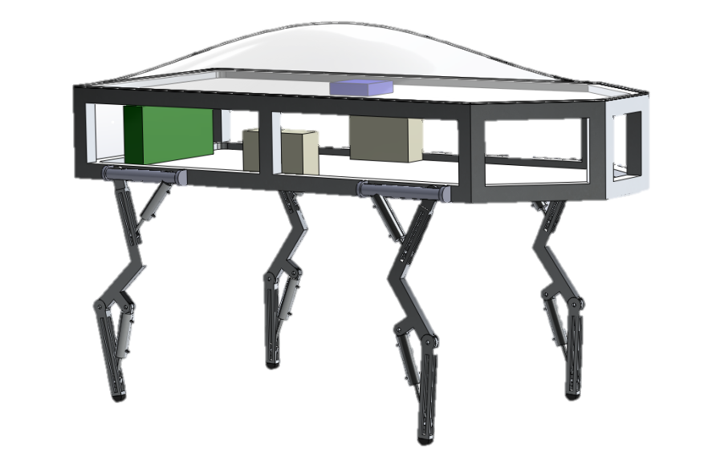



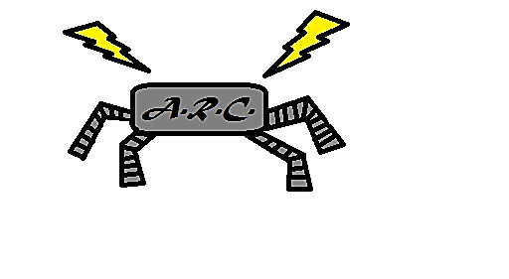

Team A.R.C. - Design Proposal

|  |  |
| --- | --- |
| Milwaukee School of Engineering | Mechanical Engineering Senior Design |

***Advisor***: Dr. Luis A. Rodriguez

***Team Members***:

Logan Beaver

Justin Campbell

Tyler Paddock

Ronald Shipman

**November 21, 2014**

Development of an Agile Robotics Platform

Contents

Executive Summary 4

Project Statement 5

Background Research 7

Locomotion 7

Number of Legs for Locomotion 8

Pneumatics vs. Hydraulics/Electrics 9

Pneumatic Components 11

Double Acting Air Cylinders 11

Air Supply Tank/Accumulators 12

Compressor 13

Air Reservoir Cartridge 13

Valves 14

Similar robots to our specifications 16

Specifications 16

Feasibility 17

Four Legs 17

Pneumatic Power Source 17

Batteries and battery life 17

Electrical Signal Components and Debugging Panel 18

Gaits and Stability 18

Size 19

Weight and Loading Capacity 20

Walking Speed 20

Microcontroller Proposal 20

Motherboard and Other Electronics 21

Signal Conditioning and Power Circuits 21

Communication System 21

Dedicated Control Loop Microcontrollers 21

Summary 22

Preliminary Design 22

Arachnea 22

Hexabot 23

Boxxy 25

DogeBot 25

Project Management 28

Timeline 28

Phase I: Design Synthesis (September 12, 2014 – November 23, 2014) 28

Phase II: Design Analysis (November 24, 2014 – March 1, 2014) 28

Phase III: Development and Testing (March 2, 2014 – May 2014) 29

Preliminary Budget 31

References 32

Tables

Table 1: Summary of Locomotion Findings 11

Table 2: Design Objectives 16

Table 3: Design Constraints 17

Table 4: Quadruped Robot Walking Speeds [29] 20

Table 5: Microcontroller Choice Matrix 21

Table 6: Design Decision Matrix 27

Table 7: Scores of Preliminary Designs 28

Table 8: Gantt Chart 30

Table 9: Initial Project Budget 31

Figures

Figure 1: Wheeled robot (NASA) [9]. 8

Figure 2: Legged robot (BBC) [10] 8

Figure 3: Bimba Original Line® Air cylinder w/ Adjustable Cushions [14] 11

Figure 4: Cylinder Cross-Section View 12

Figure 5: Smittybilt 99210-2 2.5 Gallon Air Tank [15] 13

Figure 6: Speedaire Air Compressor, 0.9 HP, 120V, 115 psi [16] 13

Figure 7: *12v DC 4mm 1/4" NPT Normally Closed Brass NBR 2-Way Solenoid Valve* [18] 14

Figure 8: Electric Solenoid Valve - Cutaway [19] 14

Figure 9: Numatics Mark 3, SPA 3, and PA 3 Series Valve [20] 14

Figure 10: 4/2 Directional Control Valve [21] 15

Figure 11: Belimo B208B : 2-Way 1/2" Brass .46 Cv Control Valve [22] 15

Figure 12: Sample pneumatic circuit for motion actuation 15

Figure 13: Statically stable leg configuration for a quadruped robot 18

Figure 14: Actuation sequence of each leg of a quadruped robot for three common walking gaits 19

Figure 15: Motherboard Sketch 22

Figure 16: Arachnae 23

Figure 17: Hexabot 24

Figure 18: Boxxy 25

Figure 19: DogeBot 26

# Executive Summary

The Milwaukee School of Engineering (MSOE) participates in Science Technology Engineering and Mathematics (STEM) outreach events for prospective students. The school will benefit greatly from having a complex robotic control system to build excitement about STEM as well as encouraging prospective students to attend MSOE. An agile pneumatic robot is not only a complicated control system that can be used to get young people excited about STEM, but it will also increase the prestige of MSOE knowing that a group of seniors attending the school were able to design and build the system from the ground up. In addition it also provides an exciting opportunity for future groups to iterate on the design and integrate new and exciting features.

To fulfill the needs of the project existing robot designs were researched to help determine the initial objectives and constraints for the project. Existing walking robots such as Boston Dynamics Big Dog and Little Dog, the Swiss Federal Institute of Technology (EPFL) Cheetah Cub, and various robots from the Massachusetts Institute of Technology Computer Science and Artificial Intelligence (CSAIL) laboratory were examined. These robots were used as a baseline comparison for the design specifications and constraints. From the robots the following constraints were found to be essential to the design.

* A maximum weight of 35 Kg for portability
* Robot fitting within a 0.75 m x 0.75 m x 1.0 m box for portability
* Custom debug panel creation to facilitate controls troubleshooting
* MATLAB and Simulink model support to allow mechanical engineering students to update control algorithms without knowledge of C/C++
* Electronic fuses and shielding to protect the robot and operator during use and maintenance
* Mechanical protection to reduce the risk of pinching and self-collision damage to the robot
* An easy to access emergency stop to quickly depower the robot
* A pressure relief valve to reduce the risk of overloading and damaging pneumatic components

The work done on this project is a continuation of the work done by Kevin Lee during the Research Experience for Undergraduates (REU) at MSOE. His work involved deriving a dynamic model for a simple quadruped robot. This work is continued by the agile robotics controls team in deriving a full dynamic model for the physical robot and integrating it with control algorithms to manipulate the robot. This resulting robot design will be implemented in actual hardware toward the end of the project.

Pneumatics were chosen over electronic and hydraulic control for a variety of reasons. Pneumatics were chosen over hydraulics due to the huge weight and maintenance needs associated with hydraulic systems. Hydraulic systems are also dirtier than pneumatic systems and pneumatic working fluid is freely available. Pneumatics were chosen over electronic systems due to the high power density of fluid power systems. This high power density comes from the inefficiencies in converting electrical energy to work. In addition fluid power systems are compliant, meaning that if a large force is applied to the pneumatic actuators the fluid can compress and deform whereas electronic actuators will suffer an increased stress.

The robot locomotion utilizes a quadruped design. Four legs were selected because of the inherent static stability of a four legged design coupled with the decreased control complexity compared to robots with additional legs over four. This will allow the robot to initially actuate a slow statically stable gait as the software architecture is developed and will eventually lead to more sophisticated gaits being developed without the need for additional hardware.

The controls implementation will initially be done using a software simulation. This allows rapid updating of the main codebase as the mechanical and electronic designs iterate. Eventually the controls will be implemented into a main microcontroller which will take user input through a human machine interface (HMI) and relay the commands to the pneumatic actuators.

Four robots were initially drafted to fulfill the design requirements. The developed robots were *Arachnia*, *Hexabox*, *Boxxy*, and *DogeBot*. The following is a list of pros and cons for each robot:

*Arachnia* is a spider-style robot draft developed to fulfill the constraints and criteria of the design. It received a score of **88.33**.

* Pros: Wide range of motion, looks good, 3 degrees of freedom per leg.
* Cons: Complicated shoulder joint design, difficult to fabricate rounded servo housings, higher cost.

*Hexabot* is a spider-style robot draft developed to fulfill the constraints and criteria of the design. It received a score of **85.48**.

* Pros: Fast component cooling, 3 degrees of freedom per leg, looks good.
* Cons: Complicated shoulder joint, higher cost.

*Boxxy* is an animal-style robot draft developed to fulfill the constraints and criteria of the design. It received a score of **91.43**.

* Pros: simplicity, low cost, easy component access.
* Cons: Not aesthetically pleasing, Only 2 degrees of freedom per leg.

*DogeBot* is an animal-style robot draft developed to fulfill the constraints and criteria of the design. It received a score of **96.19**.

* Pros: 3 degrees of freedom per leg, simplistic shoulder joint design, fast component cooling.
* Cons: Higher cost, smaller range of motion, complicated chassis fabrication

The highest scoring design was DogeBot. During the second phase of the Capstone Project design process more work will be done in refining and iterating the robot design along with the pneumatic, electronic, and control subsystems.

# Project Statement

Recently, there has been a decline in interest and proficiency related to science, technology, engineering, and mathematics (STEM) fields. According to a 2013 survey of 1,025 teens conducted by Junior Achievement USA and the ING U.S. Foundation 46% percent of all teens surveyed showed interest in pursuing either a STEM or medical related career, when compared to previous years this shows a 15% decrease in interest in STEM and medical related careers [1]. Educational robots have been shown to be excellent tools for increasing interest of STEM in younger students. In a study conducted by the University of Nebraska, 147 students participated in a week-long camp focusing on robotics related activities such as programming robots utilizing the LEGO Mindstorms NXT robotics kit. While the short term intervention did not impact student learning significantly, students’ attitudes towards STEM improved as did their self-efficacy with robotics [2].

MSOE participates in community outreach programs where STEM topics are demonstrated to encourage younger generations to enter into STEM based degrees and careers. Having an automated control system to demonstrate and interact with would increase the excitement at these outreach programs as well as influencing more students to pursue careers in STEM related fields.

In addition to decreased interest in STEM, proficiency in STEM fields is decreasing at a worrisome rate across the United States. In 2012 the Program for International Student Assessment (PISA) was given to 15 year old students across the world to compare academic proficiency between countries. The United States scored 23rd in math and 31st in science compared to 65 other industrialized countries, a worryingly low score[3].

There are two methods proposing to help increase STEM education proficiency, Process Oriented Guided Inquiry Learning (POGIL) and Engineering Design Process (EDP). POGIL is a student lead educational paradigm where teachers point students in the right direction and let them discover the lesson on their own through experimentation and research. At the end of each unit the topic is wrapped up by the teacher to ensure students have a clear understanding of the material [4]The A.R.C. robot would make a great teaching aid for a POGIL style environment. It could be used as the basis for a lesson plan in fluid power, control theory, electrical design, and many other lessons.

EDP is a learner-centered paradigm to teaching where the professor outlines a real world problem and asks students to come up with solutions based on topics covered in class. This is the type of learning typically seen in classes with laboratory time [5]. Due to the interdisciplinary nature of robotics the A.R.C. robot could be used in many introductory design applications. It could be used to enhance Electrical Engineering, Mechanical Engineering, Software Engineering, Controls, or even Fluid Power curricula. Not only could the robot and its subsystems be used to generate design problems, it’s also possible to use it as a research platform or as an example of a solution generated using the engineering design process.

During the summer of 2014, research in robotic locomotion was conducted by Kevin Lee. This research provided the basis of the mathematical modeling to develop physical gait patterns for a quadruped robot. Modeling the locomotion of the robot involved determining the dynamic motion for a single leg. With a strong understanding of a single leg all four legs were used to create a gait pattern for the robot [6]. Given this background research the focus of this project will be implement a physical system using the previous work done by Kevin Lee.

While Kevin Lee’s preliminary research in the mathematical models representing locomotion in legged robots did provide a good foundation to build upon, some assumptions made in his model must be addressed when moving forward with a specific robot design. One such assumption is that the center of mass will be centered on the design. Due to the placement of components on the chassis of the robot, the center of mass will most likely not be directly in the center of the robot. The center of mass is crucial in determining which leg placements will lead to stability. The center of mass in the links representing the legs of the robots was also assumed to be in the center of the links, which again will most likely not be the case. Other topics not covered by Kevin Lee, which will be serious considerations in the design, include velocity analysis of the legs and the weight of the pneumatic cylinders.

The objective of this project is to design a pneumatic power driven quadruped robot with the ability to walk slowly. The robot will have all of its control systems and power supply onboard. Aside from walking forward, the robot should also have the ability to walk backwards and turn to get out of corners and avoid obstacles. Other necessary features of the robot include fuses to protect hardware and a wireless communication system connected to the user’s controller. The robot should have at least one emergency stop button on both the robot itself and the controller in the user’s hands, which, upon engagement, immediately causes the robot to enter a stable condition.

# Background Research

### Locomotion

One of the first decisions to be made in the design of any mobile robot is the type of locomotion to be implemented. The choice of type of locomotion to be implemented in a robot design is dependent on desired functionality and the environment in which the design will be interacting. The types of grounded locomotion are legged locomotion and wheeled locomotion. When choosing which type of locomotion to implement in a design, the advantages and disadvantages of each must be weighed against each other. Large factors in the considerations that must be made include the intended use and the intended environment where the design will operate.

The implementation of wheels in a design requires simpler motion planning and fewer parts when compared to legged motion. An example of a wheeled robot can be seen in Figure 1, a robot designed by NASA for use in rocky, sandy lunar terrains. Wheels also provide the fastest mode of transportation on flat ground and, because the wheel is usually in contact with the ground, wheeled motion is usually more energy efficient than in legged motion [7]. Wheels do, however, struggle with rugged terrain and can lose traction, so in areas without flat surfaces, wheeled locomotion can become difficult. Situations favoring wheeled motion involve environments where the surface is flat, energy usage is critical, and high speed is favorable [7] [8].

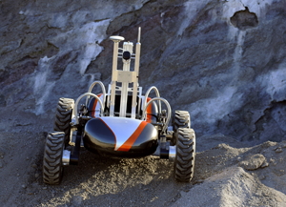

Figure : Wheeled robot (NASA) [9].

Legged locomotion, on the other hand, has high mobility on surfaces that are sloped or rugged, and is feasible means of locomotion on flat surfaces as well. This due to the ability of legged designs to step over obstacles and to move the center of gravity to adjust the distribution of weight on its supports, to compensate for different levels of flatness or ruggedness of terrain. This, however, causes the motion planning of legged motion in a design to be more challenging and more costly, due to the need of more parts. An example of a legged robot, a hydraulic powered robotic spider created by Matt Denton, can be seen in Figure 2. Legged motion also gives the design the option of changing direction without changing the orientation of the body, giving the design increased maneuverability. Situations favoring legged locomotion include environments that are rugged and generally sloped or even environments where the terrain is unknown and the ability to traverse these environments effectively is required [7] [8].

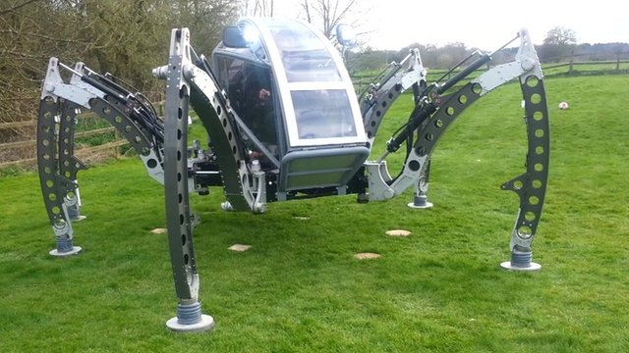

Figure : Legged robot (BBC) [10]

### Number of Legs for Locomotion

An important consideration when designing a legged robot is the number of legs. Four legs is the minimum number of legs necessary for the robot to remain statically stable while moving. However, depending on the application there may not be a need for static stability

A one legged robot is not statically stable and highly susceptible to tipping without constant motion. In order to prevent tipping complex controls must be implemented to keep the robot balanced. Additionally the robot can only travel via hopping. Therefore a one legged robot must be capable of maintaining its current position and moving along a path by only hopping [8].

A robot with two legs is more stable, since it is able to balance its center of gravity between two contact points while standing still. It can also utilize a singular contact point for balance while traveling. Compared to a one legged robot design the level of complexity required to maintain balance decreases due to the increased stability. However, due to the addition of another leg more sophisticated control software is required to control the extra leg [8]. A two legged robot must still be able to shift its center of gravity while walking to maintain balance, but there are also more modes of travel available. A two legged robot can hop, walk, and run.

A characteristic of four legged designs is the ability to remain statically stable while standing still and while walking slowly. With this ability to remain stable with one leg raised requires less complicated controls compared to robot designs with one or two legs. Attainable gaits for four legged robots include hopping, walking, running, lunging, and many more.

Robots with more than four legs are even more stable. The biggest disadvantage of a robot with more than four legs is the dramatic increase in cost and control complexity. With more than four legs the robot can remain stable throughout any gait, but the extra stability is not necessarily worth the extra design complexity and cost [8].

This robot was selected to have four legs. This achieves a good balance between the sophistication of the control design and component cost. Initially the robot will achieve a basic walking gait which will utilize the ability of the robot to remain stable with one leg off the ground. Additionally, when more complex gaits are implemented there will not be a need to acquire extra hardware, instead more complex controls will need to be implemented to take dynamic stability into consideration. To develop the walking gaits mathematical models of the robots dynamics will be created.

### **Pneumatics vs. Hydraulics/Electrics**

For the robot’s design, it was determined that the best choice for transferring power throughout our robot would be achieved using pneumatics. While other possible power sources exist, such as hydraulic and electronic sources, consideration of the advantages and disadvantages was necessary in choosing an appropriate power source. In comparing pneumatic, hydraulic and electric power sources, various restrictions and downfalls characteristic of both hydraulic and electronic sources would prove difficult for implementation in the robot’s design, thus leading to pneumatic power being the most desirable choice.

Hydraulics is the best choice when it comes to moving heavy loads immediately. With possible forces achieved being upwards of 100 tons, hydraulics is able to achieve full velocity quickly [11]. On the downside, leaks prove to be problematic in a hydraulic system. If any of the seals fail, a pressure drop in the fluid will occur, reducing the effectiveness of the system. In addition, the leaking fluid can interfere with electronic or mechanical systems near the break, creating more problems and leading to necessary replacement parts for not only the hydraulics [12]. Finally, one of the most crucial considerations for implementation of hydraulics in the robot’s design is its weight. The density of the hydraulic fluid is much greater than that of the electronics or air needed to power pneumatics, meaning the design will be much heavier than if either of the other two systems were implemented. This also means a hydraulic system needs a more powerful compressor to push the fluid through the lines, typically meaning an engine is required to power the system. Hydraulics is a good choice when power is needed, but for our design a light-weight, clean system is favorable over the extra power.

Electronics excel where absolute accuracy is needed or when a system is in continuous motion. Additionally, electronic control is the best when it comes to repeatability of the system. If only two or three positions are needed, fluid power can be extremely accurate and repeatable, with pneumatics remaining accurate to +/- 1 mm for systems needing more than three positions [12]. However, due to the compressibility of the working fluid, exact positioning of the cylinders may not always be possible. Electronics offer the greatest number of possible accurate positions, especially when a closed loop is used and the system can adjust itself between iterations [13]. The downfalls for electronics are that if linear motion is required, a transition is typically required since electronics are normally motor driven, and the power factor and ability to apply constant pressure are low for electronics compared to fluid power, because in electronic components applying constant forces can result in hardware damage due to overheating. Electronics are best suited for a system needing control, not power. For our robot, both qualities are necessary, therefore electronics are not the best choice.

Pneumatics is compromise between hydraulics and electronics. It retains the ability to apply large amounts of constant pressure while maintaining control and accuracy within the system. Pneumatics also has the added benefit of being cleaner than hydraulics. If a leak appears, the system for the most part remains unaffected. Electrical and mechanical components are not likely to be damaged by escaping air and the power loss is negligible for small leaks. Even while maintaining its power, pneumatics remains accurate and repeatable. Also like electronics, pneumatic systems are easily exchangeable and are inherently modular, allowing for future expansions on an existing system with few problems. Overall, pneumatics offers the best power and accuracy of the three systems in addition to being lightweight and clean.

Table 1 summarizes research findings related to possible locomotion choices and the advantages and disadvantages related to each choice.

Table : Summary of Locomotion Findings

|  |  |  |
| --- | --- | --- |
|  | **Advantages** | **Disadvantages** |
| **Wheeled Locomotion** | -Less complex motion  -Fastest on flat ground | -Bad for rough terrain (uneven, sloped, rocky) |
| **Legged Locomotion** | -Better for rough terrain (uneven, sloped, rocky)  -Good obstacle avoidance  -Precise feet positioning | -More complex motion  -High control complexity |
| **1 Legged** | -Lower cost due to fewer components | -Complexity in controls due to static instability  -Can only hop |
| **2 Legged** | -Marginal static stability  -More achievable gaits (walk, run) | -Complex balance control |
| **4 Legged** | -Statically Stable | -Complicated leg synchronization controls |
| **More than 4 Legged** | -Statically Stable | -Very complicated leg synchronization controls  -Very high cost for additional components |
| **Hydraulic Power Source** | -Highest achievable power density | -High maintenance  -Heavy  -Dirty |
| **Electric Power Source** | -Accurate positioning | -Lowest achievable power density  -Noncompliant |
| **Pneumatic Power Source** | -Higher power density than electric power  -Low Maintenance  -Compliant action from fluid compression | -Compressible fluid causes inaccuracy in positioning |

### **Pneumatic Components**

In order to successfully design a user controlled, pneumatic powered quadruped robot, various electrical and fluid power components must be utilized. These components make up the subsystems that eventually are combined to make up the robot itself. Fluid power components include the air supply tank, the air compressor, the tubing, the double acting air cylinders, the reservoir tank, solenoid valve, and control valves.

### **Double Acting Air Cylinders**

Unlike with single action air cylinders, double acting air cylinders are able to receive pressurized air to both extend and contract. Without utilizing a double acting air cylinder, controlled contraction of the legs of the robot would not be possible. Contraction through some forcing mechanism such as a spring would provide contraction of the leg, however the contraction would not be controllable, as the spring would simply want to return to its un-stretched length as fast as possible, thus varying walking patterns would be challenging.

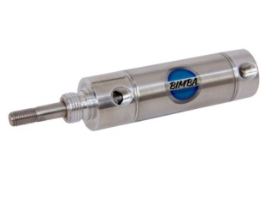

Figure : Bimba Original Line® Air cylinder w/ Adjustable Cushions [14]

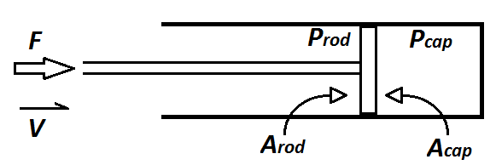

Figure 4: Cylinder Cross-Section View

The equation to find the amount of force produced by the pneumatic circuit is as follows:

 (1)

Where Pcap is the pressure on the cap side of the cylinder, Acap is the area of the piston head, Prod is the pressure on the rod side of the cylinder, and Arod is the surface area of the piston head on the rod side. In addition to finding the possible force output of the cylinder, it is also important to be aware of its efficiency. The cylinders efficiency can be influenced by a number of factors such as seal friction, viscous friction, leakages, and fluid compressibility, which can all contribute to the cylinders energy losses. The efficiency of the cylinder is determined using the equation:

 (2)

For the efficiency equation, Pin and Pout are the power into and out of the system, respectively, Qin is the heat flow into the system, and V is the velocity of the cylinder.

### **Air Supply Tank/Accumulators**

Accumulators are the potential energy storage elements for fluid. They provide pressurized fluid during brief, high-demand periods. The compressed fluid is pushed into the accumulator by the compressor, and the fluid compresses either a steel spring or a compressed gas bladder to store the energy. Accumulators are useful when it comes to smoothing out pulsations from the compressor, absorbing pressure surges to maintain a steady flow out to the components. Accumulators maintain a high power density, but only a modest energy density, and should be located close to the input for the Directional Control Valve (DCV) to prevent large pressure drops. The amount of energy stored within an accumulator depends on whether it is an Isothermal or Adiabatic case. The following equations are used to find the energy storage in an accumulator.

 (3a)

 (3b)

In both cases, P is the pressure in the accumulator, V is the volume of the tank, and v1 and v2 are the volume of the compressed gas before and after compression, respectively.

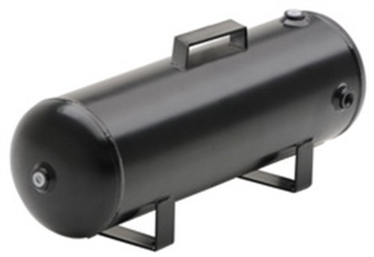

Figure : Smittybilt 99210-2 2.5 Gallon Air Tank [15]

### **Compressor**

Compressors draw in air from the outside, and pressurize it by compressing it using either a small engine or an electric motor. The compressor feeds the pressurized air into an accumulator to store the pressurized air until it is needed and also to eliminate the pressure fluctuations produced before they are put into the system. Compressors suffer from a number of inefficiencies resulting in energy loss. A typical equation to find the efficiency of an air compressor is:

 (4)

Where ɳC is the compressors efficiency, Pin and Pout are the input and output pressures of the air, and Tin and Tout are the input and output temperatures of the air. All compressors and air supply tanks come equipped with a relief valve, a small valve kept normally kept closed by a spring, that opens to release some of the built up pressure if it becomes too great.

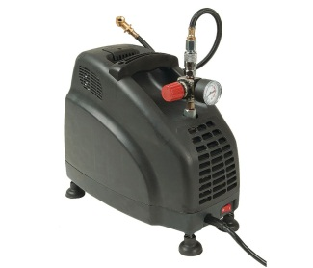

Figure : Speedaire Air Compressor, 0.9 HP, 120V, 115 psi [16]

### **Air Reservoir Cartridge**

The air reservoir cartridge holds a supply of pressurized air received from the air compressor. The air reservoir cartridge is used to equalize the flow through the pneumatic circuit of the robot, thus maintaining constant flow of pressurized air through the robot’s pneumatic circuit. A constant flow rate of pressurized air through the robot’s pneumatic circuit translates into constant forces through the air cylinders.

### **Valves**

The main function of the solenoid valve is to either turn on or shut off the total flow in the pneumatic circuit. Solenoid valves can be controlled a number of ways, such as by air pressure and electrically [17]. Utilizing electrical current, a coil is activated, allowing flow, and thus without the electrical current, the coil is not activated and there will be no flow. In solenoids controlled by air pressure, the solenoid will only allow flow when a certain pressure, determined by the specific design, is experienced by the solenoid.

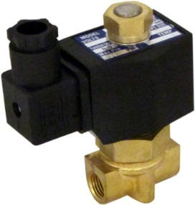

Figure : *12v DC 4mm 1/4" NPT Normally Closed Brass NBR 2-Way Solenoid Valve* [18]

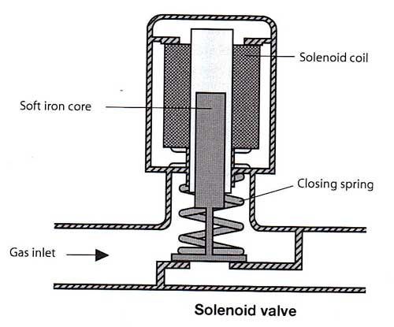

Figure 8: Electric Solenoid Valve - Cutaway [19]

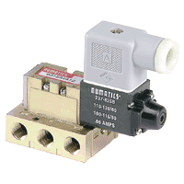

Figure : Numatics Mark 3, SPA 3, and PA 3 Series Valve [20]

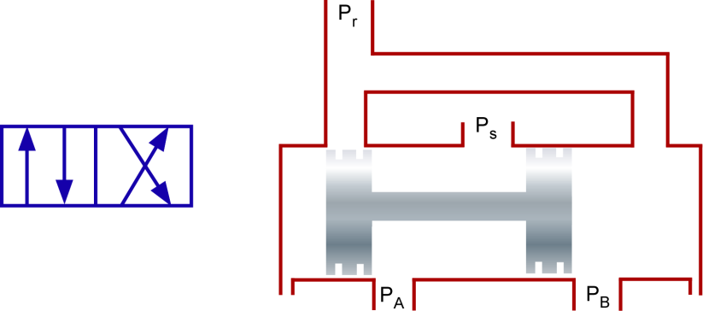

Figure 10: 4/2 Directional Control Valve [21]

Directional control valves (DCV) allow free flow in one direction but restrict flow in the opposite directions, when air is flowing. A 4/2 DCV is necessary to allow flow in two directions allowing the cylinder to extend and contract. A 4/2 DCV means that there are 4 ports and 2 switch positions, as can be seen in Figure 10. Depending on the position, supply air will either go to port A or B, while the other port is connected to the exhaust line, allowing the cylinder to move in both directions.

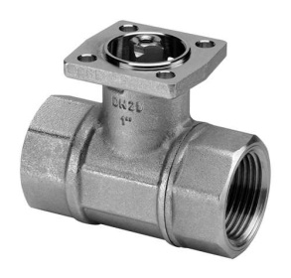

Figure : Belimo B208B : 2-Way 1/2" Brass .46 Cv Control Valve [22]

An example circuit for a single leg cylinder is given in Figure 9. The reservoir tank attaches to the solenoid valve using a tether to reduce the mechanical load on the robot.

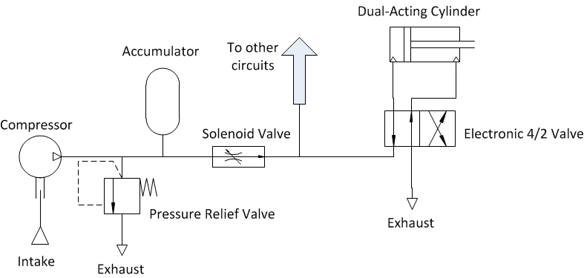

Figure : Sample pneumatic circuit for motion actuation

**Figure 9 shows an example pneumatic circuit for one robotic leg. The compressor, pressure relief valve, and accumulator are tethered to the robot using a high pressure line. The compressor takes air and pushes it into the accumulator tank to ensure a steady air supply during operation. The pressure relief valve opens if the system pressure is too high. The solenoid valve is electronically controlled by the robot’s processor and turns flow into the robot on and off. The electronic 4/2 valve is actuated by the microprocessor to control the position of a dual acting cylinder. Each electronic valve is setup in parallel to actuate the dual acting cylinders attached to each leg. The high pressure gas then leaves the system through an exhaust port in the robot.**

### **Similar robots to our specifications**

Walking quadruped robots are an area that has been expanding quickly for the past few years. With such successes as Boston Dynamics “Big Dog”, the number of quadruped robots being produced and tested has increased significantly. There are two distinct types of quadruped walking robots: spider and mammal. Spider robots have a small central body with the legs coming out at 90° from each other, whereas mammal inspired quadrupeds have a rectangular body with all for legs on the two long sides: two in the front and two in back.

The Cheetah-Cub robot is one example of a mammal quadruped. Produced by the Swiss Federal Institute of Technology in Lausanne (EPFL), this small quadruped was designed to try and improve the biological likeness of robotic motor skills. This robot is powered explicitly by servos and the developers studied slow motion images of horses to create sequential gait cycles for a walk, trot, and gallop. The procedure worked for the first two gait types with the third, the gallop, proving more difficult due to the fact that real quadruped mammals flex their spine when running. The next step for the researchers at the EPFL is to make a robot that more accurately approximates the anatomy of the animal they are trying to mimic in order to try and improve their results [23].

# Specifications

Constraints and objectives were created based on desired functionality and portability to direct the design of the agile quadruped robot. Objectives are criteria that the robot must meet in order to be considered complete. Constraints are hard limits on certain portions of the design. Table 2 summarizes the design objectives and Table 3 lists designs constraints.

Table : Design Objectives

|  |  |
| --- | --- |
| **Objective** | **Success Criteria** |
| Brown Out Conditions | Robot enters stable condition on electrical failure |
| Emergency stop button | Robot should be able to completely shut down with one button push |
| Fuses | Fuses on robot to protect components |
| Wires organized and secured | Wires should be insulated and protected from mechanical pinching |
| Robot self-collision avoidance | The robot should not be able to hit itself |
| Onboard Batteries | All batteries must be on the robot chassis |
| Number of legs | 4 legs |
| Mechanical Power System | Pneumatics |
| Can walk on a flat surface | Robot should be able to walk on a flat surface without problems |
| Easy debugging of signals | Pneumatics should have an electrical panel to debug the electrical signals |
| Robot walks backward | The robot should be able to move backward |
| Controlled via a user interface | Movements are controlled w/ a user-interface |

Table : Design Constraints

|  |  |
| --- | --- |
| **Constraint** | **Success Criteria** |
| Load Weight | Carry at least 1.25 its own weight safely |
| Walking Motions | Robot should have at least a creep gait |
| Maximum Walking Speed | 0.5 [m/s] |
| Weight | 35 [kg] |
| Size | 1 [m long] 0.75 [m tall] .75 [m wide] max |
| Battery Life Pneumatics | 3 hours at least |
| Cost Constraint | $10000 max |
| System Startup Time | Starts in less than one minute |
| Recover from disturbances | Robot remains stable even if disturbed up to 10N |
| Battery Life Microcontroller | 2 months at least |

# Feasibility

### **Four Legs**

The implementation of four legs in the design of the agile robot is a sound decision both financially and technically. With more than for legs the project budget will increase due to the extra components required for the additional legs. With less than for legs maintaining the stability of the robot will become more complicated and will require additional sensors, increasing the budget. With four legs, stability is fairly easy to maintain as the robot takes a step.

### **Pneumatic Power Source**

When comparing pneumatics to other forms of power transfer, such as electronics, through servos, and hydraulics, pneumatics provide a greater force and speed per unit size than servos, while also being lighter, cheaper and easier to maintain than hydraulics. More specifically, with the correctly chosen pneumatic power source, the forces required to support the weight of the robot are easily obtainable.

### **Batteries and battery life**

The robot is specified to contain all batteries needed for its power circuits. Small AA batteries can be used to power the microcontroller and other small components like analog to digital converters and filters. Two different twelve volt rechargeable batteries can be used in series to provide twenty four volts to the pneumatic components, which are specified at an operating voltage of twenty four volts. The battery lives can be calculated by taking the average consumption in amps and multiplying by the number of expected hours of operation. The robot would require batteries with high enough amp hours to meet the three hour battery life for the pneumatics and the two month battery life for the microcontroller.

### **Electrical Signal Components and Debugging Panel**

The electrical signal for each leg will be connected to a custom panel for testing and debugging. The panel will use banana plug connectors. This is because banana plugs are used within the Milwaukee School of Engineering’s labs.

### **Gaits and Stability**

In order to achieve stability for an agile walking robot, a concept known as the Zero Moment Point (ZMP) was developed [24]. The ZMP is the position on the ground where the moment created by the robot’s feet is zero. For a stationary or slow moving robot this position coincides with the center of mass.

In order for the robot to remain stable the ZMP must remain within the convex shape created by the robot’s feet in contact with the ground. This shape is known as the support polygon. If the robot’s ZMP is outside of the support polygon it will create a tipping moment and the robot will become unstable. An example of a stable support polygon is given below [25]:



Figure : Statically stable leg configuration for a quadruped robot

In order to achieve an agile walking gait the path of the ZMP path must be tightly controlled [26]. There are two families of gaits, walking and running. The A.R.C. robot will use a walking gait due to their lower control complexities and higher static stability. The three main robotic walking gaits are the crawl, trot, and pace. A summary of the leg actuation for each gait is given below [27]:

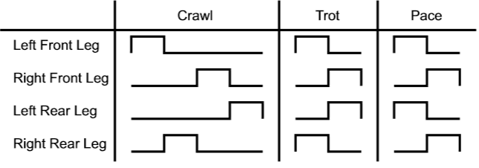

Figure : Actuation sequence of each leg of a quadruped robot for three common walking gaits

The crawl gait is the only statically stable gait due to the support polygon created by the three feet remaining on the ground. The biggest drawback of the crawl gait is the slow overall speed of the robot. Because only one leg is actuated at the time the maximum walking speed is ¼ the speed of each leg.

The trot is marginally statically stable. Two diagonal legs across from each other form a line and if this line passes through the ZMP there is no tipping moment created. However this gait is dynamically stable due to the cyclical nature of gaits. As the robot moves forward the ZMP will travel across the support line created by the feet, cancelling the tipping moments out. The trot has a much higher control complexity than the crawl gait, but it is also much faster.

Pacing involves lifting two legs simultaneously on the same side. This gait is statically unstable as the support polygon is entirely on one side of the robot. This leads to the robot swaying back and forth as it walks as each actuated tips. This gait is marginally faster than the trot while having a much higher control and dynamic complexity.

Due to the small control complexity and statically stable nature of the crawl gait it will be the primary gait developed for the project. Given only one leg is actuated at a time for the crawl gait, it will be the fastest to implement in order to test the control software. Due to the static nature of the gait it can also be assumed that the robot is always in a stable configuration during initial development.

After the crawl gait is implemented, additional sensors will be integrated into the system to detect and respond to system instability. This will allow the robot to not only react to external disturbances, but also allow it to remain upright while more complex gaits are actuated. Due to the statically unstable nature of faster gaits, the problem of recovering from instabilities must be solved before additional gaits are implemented to avoid damage to the robot.

### **Size**

When constraining the size of the robot, the idea of portability was in mind. The robot needed to be able to be moved relatively easy and it also needed to be able to fit in restricted spaces, such as a car trunk or storage closets. Robot sizes vary depending on application and budget restrictions. For example the robot BigDog from Boston Dynamics is about 1.0 meter and 0.75 meters tall. This robot is intended to be a pack-mule robot, carrying supplies through precarious terrain. Cheetah-Cub on the other hand, being 0.15 meters tall and 0.2 meters long, was intended for natural locomotion research. The decided size limit kept in mind related quadruped robots, but was based heavily on the intent of the robot being demonstrational leading to a portable size specification. By looking at other quadruped robots this smaller size seems feasible.

### **Weight and Loading Capacity**

In order to keep the robot portable a light weight material such as aluminum will be used for is chassis. One of the most widely used Aluminum alloys is 6061 Aluminum. This alloy has yield strength of 276 MPa [28], and due to its high yield strength and small forces acting on the robot it is unlikely that the legs will suffer a structural failure during operation. Aluminum’s ductility and flexibility is also an advantage when fabricating the robot’s structural components.

### **Walking Speed**

A walking speed of 0.5 meters per second as a minimum should be well within the capabilities of the robot when compared to other quadruped robots. Comparable robot walking speeds and corresponding weights can be seen in Table 3. Judging by the speeds accomplished by other designs our minimum speed requirement of 0.5 meters per second seems feasible.

Table : Quadruped Robot Walking Speeds [29]

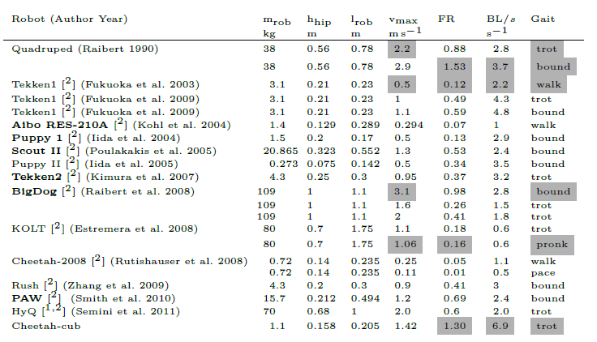

# Microcontroller Proposal

The microcontroller in this system is used to provide the control and user interface. Four microcontrollers were analyzed the Arduino, Raspberry Pi, Beagleboard, and Tiva. Important factors in deciding the microcontroller were the speed of the processor, number of analog inputs, MATLAB compatibility, and others. The decision matrix that was used to score the microcontrollers is given in Table 4.

Table : Microcontroller Choice Matrix



After scaling each factor to sum to 1, each microcontroller was analyzed and scored out of five for each criteria. Each row was then summed to calculate the total score for each controller. The top microcontroller was the Arduino Mega with a score of 3.8. The second best microcontroller was the Tiva series controller from Texas Instruments with a score of 3.7.

# Motherboard and Other Electronics

### **Signal Conditioning and Power Circuits**

The motherboard of the system will include any filters and packaged chips like analog digital converters (ADC) or digital to analog converters (DAC) needed for signal conditioning or analysis. Each pneumatic valve is controlled by an analog signal. Assuming two valves per leg there will be eight valves or eight analog signals. The microcontroller uses digital signals, so the digital signal will have to be converted in one of two ways. The first way would be to use a DAC package. The second solution would be to take a pulse width modulated (PWM) signal from the microcontroller and send it through a low pass filter to form an analog voltage at the output of the filter. From this point the signal might need to be sent through an amplifier to increase the amplitude of the voltage. The microcontroller will need to be isolated from the pneumatic power circuit, so relays or isolation amplifiers will need to be used to isolate the two power circuits.

### **Communication System**

In addition to any signal conditioning, there must be a wireless communications channel to allow a user to interact with the robot remotely. This communications channel will be added to the custom motherboard and interface with the microcontroller. Choosing the communications system is difficult given the multitude of options. Two capable communication systems work on the Bluetooth standard specified by the Institute of Electrical and Electronics Engineers (IEEE) 802.15.1 and the Zigbee standard specified by IEEE 802.15.4. Bluetooth has the advantages of being higher speed and has the capability to have multiple master slave relationships. The Zigbee standard is the lower power solution which is favorable in remote applications where high data rates are not needed. A disadvantage of the Zigbee standard is a limitation to only one master device, but for this application only one master device [30] [31]. Given the listed advantages and disadvantages, the Zigbee IEEE 802.15.4 standard is the leading choice for a communication system.

### **Dedicated Control Loop Microcontrollers**

**If the main controller runs too slowly to handle the control loop for all of the actuators smaller microcontrollers can be used to handle them. Each microcontroller will have three instances of a PID controller executing on the hardware. This technique would be a simple solution to reduce the processing demand on the main microcontroller driving the robot and its movements. It would also increase the responsiveness of the robot due to the faster leg control update tame. It is important to note that these smaller dedicated control loop microcontrollers may not be needed. However, at this stage in the project the necessity of the extra dedicated microcontrollers cannot be determined.**

### Summary

The motherboard contains all signal conditioning, protection, and communications. A rough sketch of the motherboard can be seen in figure 12. Power calculations cannot be done since the components are not picked. Power calculations for the pneumatic actuators are also not possible because the valves consume the most energy when moving position. An analysis must be done to find the average power consumed by one leg walking for a minute. With that average taken the power consumption of the pneumatic circuit can be calculated by multiplying the average power per leg by four, the number of legs.

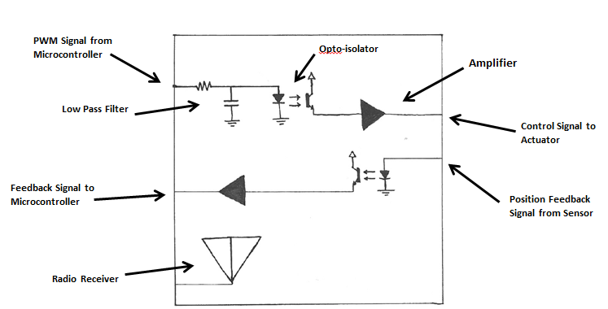

Figure : Motherboard Sketch

# Preliminary Design

### Arachnea

*Arachnea* is another spider style robot. It utilizes vertical servo shoulders to rotate the legs and attached pneumatic cylinders to desired orientations. These vertical servos also assist in aligning the top and bottom halves of the chassis. This feature allows the legs to rotate nearly 270 degrees around the chassis, giving the robot a massive workspace for positioning its feet. Due to the construction of the legs, the robot can also lay flat on the ground or double its effective height. The entire system is cooled by small fans mounted on vents inside the chassis.

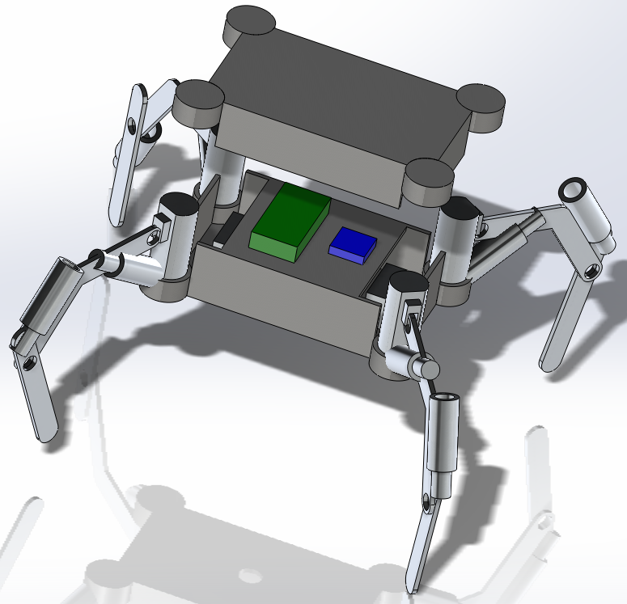

**Microcontroller**

**Pneumatic Valves**

**Upper Link**

**Lower Link**

**Internal Electrical Components**

**Servo Housing**

Figure : Arachnae

Pros:

* Servos help to align upper and lower body halves
* Symmetry enhances robot stability
* Legs have wide range of motion in X-Z plane due to positioning and degrees of freedom (12)
* Chassis (with grating) allows good airflow to internal components

Cons:

* Fabrication of shoulder joint/servo housing is complicated
* Lofted chassis design makes maintaining pneumatic components difficult
* Legs may interfere with each other

### Hexabot

The *Hexabot* design is influenced by a spiders shape. The name *Hexabot* is given due to the hexagonal chassis design. The legs are positioned along the sides of the hexagon chassis and have three degrees of freedom. Two rotation degrees of freedom, about the x-z plane, achieved with use of pneumatic cylinders attached to the legs. The last degree of freedom comes from a rotation along the y-axis, achieved through the use of servo motors attached to the bottom of the chassis. The feet of the robot are simple rubber spheres to ensure there is enough friction in the feet of robot to avoid slipping. While this design displays an open cage-like chassis grating will be attached along the sides of the chassis to closed off and protect the internal components of the robot. One pneumatic cylinder will be attached to the servo housing and the upper leg link. Another pneumatic cylinder will be attached to the upper link and the lower link. This orientation of the air cylinders will ensure the legs can bend at the knees and the hips and also have rotation about the hip from the servo motor.

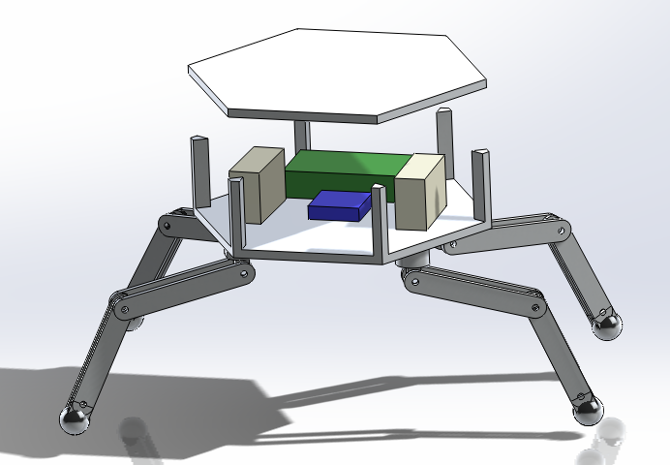

**Y**

**X**

**Z**

**Servo Housing**

**Upper Link**

**Foot**

**Lower Link**

**Internal Electrical Components**

**Chassis**

Figure : Hexabot

Pros:

* Positioning of servos below the chassis helps avoid interference in leg motion
* Fairly symmetric shape increases stability
* Legs have wide range of motion in X-Z plane due to positioning and degrees of freedom (12)
* Feet allow adequate friction when legs are in contact with ground at various orientations
* Chassis (with grating) allows good airflow to internal components
* Most components can be easily manufactured and assembled

Cons:

* Not attractive (plain looking)
* Construction of servo housings may be difficult
* Hexagonal shape reduces available internal space for electrical components
* Legs can interfere with each other due to range of motion

### Boxxy

The *Boxxy* design is influenced by the simplicity of an open box. The name *Boxxy* is given due to the resemblance to an open box. The legs are attached directly to the side of the chassis to decrease the joint complexity. The first pneumatic cylinder is attached using revolute joints to the chassis and first link of the leg. The second cylinder attaches the first and second link using additional revolute joints. This leads to a simple design which a low maintenance requirements. The open topped design also allows easy access to all components.

**Internal Electrical Components**

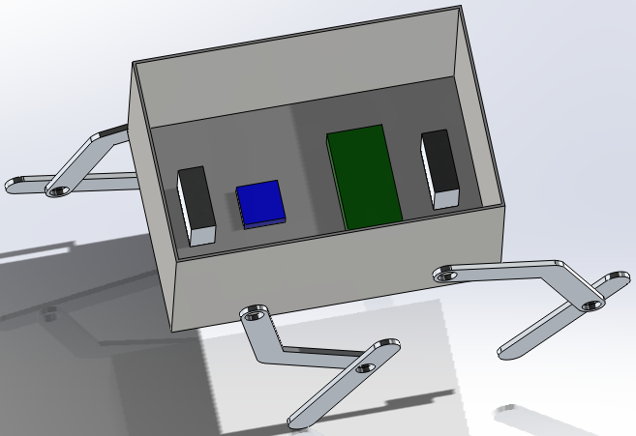

**Microcontroller**

**Lower Link**

**Upper Link**

**Pneumatic Valves**

Figure : Boxxy

Pros:

* Simple cheap design
* Easy to manufacture
* Easy to access components
* Simple to maintain

Cons:

* Ugly
* Limited range of motion and disturbance resistance
* Legs can interfere with each other
* Limited airflow through chassis

### DogeBot

The *DogeBot* design is based off a four legged mammal, more specifically a dog. The legs bend at the knee and the hip using pneumatic air cylinders. The orientation of the cylinders will prevent the pneumatic lines from getting close to any “pinch-points”, so as to avoid damaging the robot during operation. A third degree of freedom for each leg comes from a servo in the “shoulder”, allowing the robot to move its leg in and out from its body to assist in turning and stabilization. The chassis is open on the sides, allowing the user to access the pneumatics and electronics without taking the entire robot apart. The feet are made of rubber to increase the grip of the robot when walking to avoid slipping on smooth surfaces and inclined planes.

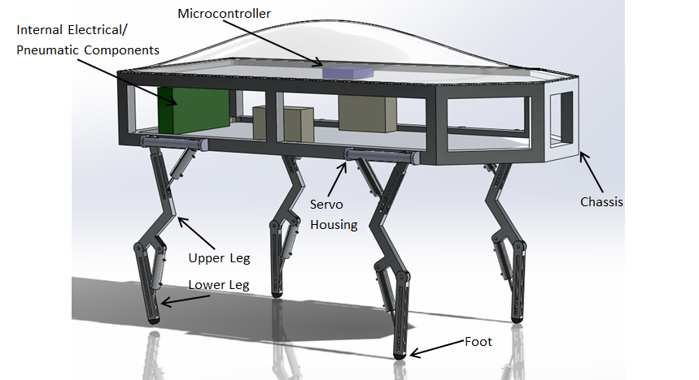

Figure : DogeBot

Pros:

* Legs cannot interfere with each other
* Open siding (with grates) allows for good airflow and accessibility
* Load kept off of servos using bearings
* Symmetric layout allows for easily centering weight
* Adequate space for components within robot’s chassis
* Leg and chassis shapes easily manufactured

Cons:

* Large size puts the robot near the weight limit
* Slender legs may be susceptible to bending
* Plastic covering may be difficult to design and construct

The preliminary design is chosen out of the many potential designs using the following decision matrix in Table 5. The categories are given with a weight between one and five and given a max score. Each component is then given a score that is then normalized and multiplied by the weight to get the final weighted score.

Table : Design Decision Matrix

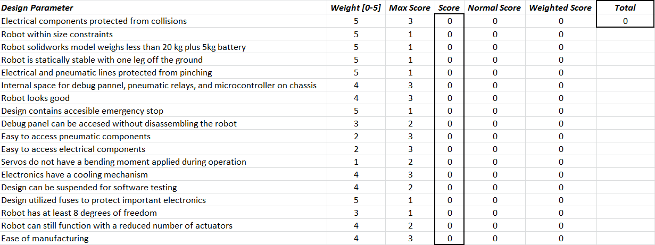

Design parameters and weights were decided by considering important characteristics and overall functionality of the robot. Parameters were also decided with major constraints in mind, such as those related to user and robot component safety. Examples of parameters related to safety are “Design contains accessible emergency stop” and “Electronics have a cooling mechanism”. Considering these parameters are crucial to key functionality and safety in the operation of the robot, the weights are appropriately high. The parameter “Servos do not have a bending moment applied during operation” has the lowest weight because, while bending moments will significantly affect the servos, their presence will not severely hinder the robots intended functionality.

The chosen preliminary design was DogeBot due to its overall highest score, shown in Table 6. This high score was due to the overall aesthetic appeal of the robot, the easy accessibility of internal components and the debugging panel, and easy to manufacture legs and chassis when compared to other proposed designs.

Table : Scores of Preliminary Designs

|  |  |
| --- | --- |
|  | **Score** |
| **Arachne** | 88.33 |
| **Hexabot** | 85.48 |
| **Boxxy** | 91.43 |
| **DogeBot** | 96.19 |

# Project Management

A project management strategy will be used to ensure full and punctual completion of the project. The following timeline, gantt chart, and budget are the preliminary tools synthesized to keep the project on track throughout the year.

# Timeline

### Phase I: Design Synthesis (September 12, 2014 – November 23, 2014)

1. Research existing walking robot designs
2. Generate constraints and objectives for the robot
3. Determine feasibility of project with a feasibility study of existing robots
4. Create initial models of components to confirm project feasibility
5. Synthesize initial design solutions
6. Formulate decision matrix for final design selection
7. Compile design report detailing the constraints, criteria, feasibility study, and final design

### Phase II: Design Analysis (November 24, 2014 – March 1, 2014)

1. Create advanced models of components to optimize the design
2. Perform a system response analysis on critical components
3. Develop base software architecture
4. Configure electrical wiring diagram for the robot
5. Develop communication architecture from HMI to controller
6. Determine final sizes and configuration of components
7. Use final models to develop idealized control algorithms
8. Present final design

### Phase III: Development and Testing (March 2, 2014 – May 2014)

1. Construct robotic leg components
2. Modify leg gains to optimize control algorithm
3. Construct robotic chassis
4. Mount components on chassis
5. Mount legs on chassis
6. Construct robot tether
7. Test and finalize control algorithms

Table : Gantt Chart

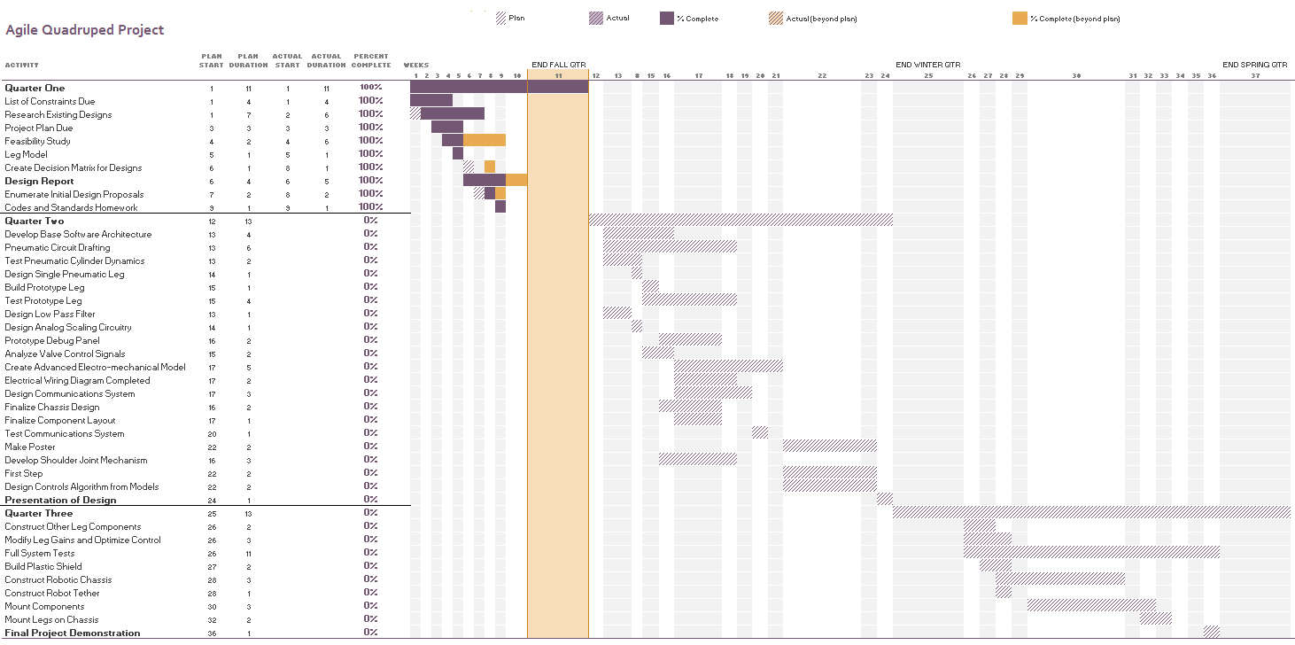

# Preliminary Budget

The initial budget of the project is $9380. A breakdown of the project costs is shown in Table 9.

Table : Initial Project Budget

|  |  |
| --- | --- |
| Item | Cost |
| Proportional directional control valves (8) | $4400 |
| Double acting piston feedback cylinders (8) | $3600 |
| Air Compressor | $150 |
| Single solenoid valve | $100 |
| Reservoir cartridge | $30 |
| Rechargeable batteries | $200 |
| Microcontroller | $100 |
| Aluminum for frame/chassis | $500 |
| Miscellaneous hardware/electronic components | $300 |
| **Total Cost:** | **$9380** |

Some possible sponsors for this project include the National Fluid Power Association (NFPA), MSOE’s Fluid Power department, Johnson Controls Inc., Joy Global Inc., and Numatics. NFPA offers grants for educators and students involved in fluid power projects. MSOE offers funding for senior design projects, especially those related to student outreach. Johnson Controls and Joy Global are both interested in the complex control and electronic systems used in robotics, and are also motivated by the positive public relations that come with helping to fund a senior design project. Numatics is a company specializing in pneumatic components who may be willing to donate the expensive valves and actuators needed for locomotion.

# References

|  |  |
| --- | --- |
| [1] | Junior Achievement USA, "New Survey Shows Teens Losing Interest in STEM Careers While U.S. Projects Significant Growth In Field," 4 June 2013. [Online]. Available: https://www.juniorachievement.org/web/ja-usa/news/-/asset_publisher/bDhKgc7S1q3z/content/id/68402. |
| [2] | V. I. Adamchuk, B. S. Barker, N. Grandgenett and G. Nugent, "Impact of Robotics and Geospatial Technology Interventions of Youth STEM Learning and Attitudes," Teacher Education Faculty Publications, 2010. |
| [3] | S. Dillon, "In PISA, Top Scores from Shanghai Stun Experts," The New York Times, 7th December 2010. [Online]. Available: http://www.nytimes.com/2010/12/07/education/07education.html?pagewanted=1&_r=0. [Accessed 20 November 2014]. |
| [4] | POGIL, "POGIL | Home," POGIL, 2014. [Online]. Available: https://pogil.org. [Accessed 19 November 2014]. |
| [5] | J. H. T. O. T. C. Kristeb Billar, "Teaching STEM by Design," *Advances in Engineering Education,* vol. 4, no. 1, p. 21, 2014. |
| [6] | K. Lee, "The Mathematical Model and Computer Simulation of a Quadrupred Robot," Milwaukee School of Engineering , Milwaukee, Wi, 2014. |
| [7] | M. H. Raibert, Legged Robots that Balance, MIT Press, 1986. |
| [8] | M. F. Silva and J. A. Tenreiro Machado, "An Overview of Legged Robots," Inistitute of Engineerning of Porto, Porto, Portugal. |
| [9] | CMU, "Lunar Prospecting Robot To Be Field Tested on Hawaii's Mauna Kea," October 2008. [Online]. Available: http://www.cmu.edu/news/archive/2008/October/oct14_scarabhawaii.shtml. [Accessed November 2014]. |
| [10] | Z. Kleinman, "Huge six-legged robot built in UK by enthusiast," 22 April 2013. [Online]. Available: http://www.bbc.com/news/technology-22231365. [Accessed Novermber 2014]. |
| [11] | T. Goel, "Advantages of Pneumatics over Hydraulics," 7 September 2011. [Online]. Available: http://www.brighthubengineering.com/fluid-mechanics-hydraulics/19006-advantages-of-pneumatics-over-hydraulics/. [Accessed 15 September 2014]. |
| [12] | Rexroth Bosch Group, "Electric, Hydraulics, Pneumatics: Evaluating Their Advantages for Automaotive Manufacturing Processes," 2006. [Online]. Available: http://dc-america.resource.bosch.com/media/us/trends_and_topics_2/technical_papers_archive/Rexroth_Elec_Hyd_Pneu.pdf. [Accessed 15 September 2014]. |
| [13] | G. Guajardo, "When is it More Efficient to Use Electric Actuators and When Are Pneumatics Better?," 28 November 2012. [Online]. Available: http://www.nfpa.com/events/pdf/2012_eehpc/ppt/08_guajardo-electric%20vs.%20pneumatic.pdf. [Accessed 15 September 2014]. |
| [14] | Bimba Manufacturing, "Original Line® Air Cylinder," [Online]. Available: http://www.bimba.com/Products-and-Cad/Actuators/Inch/Round-Line/Non-Repairable/Original-Line-Cylinder/. |
| [15] | Amazon.com, "Smittybilt 99210-2 Gloss Red 2.5 Gallon Air Tank with Fittings," [Online]. Available: http://www.amazon.com/Smittybilt-99210-2-Gloss-Gallon-Fittings/dp/B003EP2XA8/ref=sr_1_12?s=automotive&ie=UTF8&qid=1414677953&sr=1-12&keywords=air+supply+tank. |
| [16] | Grainger, "SPEEDAIRE Air Compressor,0.9 HP,120V,115 psi," [Online]. Available: http://www.grainger.com/product/SPEEDAIRE-Air-Compressor-25F537?s_pp=false&picUrl=//static.grainger.com/rp/s/is/image/Grainger/25F537_AS01?$smthumb$. |
| [17] | Norgen Fluid Controls, "Solenoid Valve Basics," [Online]. Available: http://www.pacontrol.com/download/Solenoid%20Valves%20Basics.pdf. |
| [18] | Amazon.com, "12v DC 4mm 1/4" NPT Normally Closed Brass NBR 2-Way Solenoid Valve," [Online]. Available: http://www.amazon.com/12v-Normally-Closed-Brass-Solenoid/dp/B005EP0WAO. |
| [19] | Upperplumbers, "Safety Devices and Controls," Upperplumbers, 12 March 2013. [Online]. Available: http://www.upperplumbers.co.uk/plumbing/plumbing_pages.php?title=Safety%20Cut-off%20Devices&cat=1. [Accessed 21 November 2014]. |
| [20] | Emerson Industrial Automation, "Mark 3, SPA 3, and PA 3 Series Valve," [Online]. Available: http://www.numatics.com/applications/products/valves/mk3.aspx. |
| [21] | Design Aerospace LLC, "Directional Control Valve, Hydraulic - Description," Design Aerospace LLC, 2013. [Online]. Available: http://www.daerospace.com/HydraulicSystems/DirectionalValvesDesc.php. [Accessed 21 November 2014]. |
| [22] | Energy Control, "Belimo 2-Way 1/2 Inch Brass CCV Assembly," [Online]. Available: http://www.energycontrol.com/Belimo-B208B-CCV-Control-Valve-p/B208B.htm?gclid=CPPn7OeGg8ICFYZm7Aod7F4AQg. |
| [23] | J. Falconer, "Chettah-Cub Quadruped Robot Learns to Walk, Trot Using Gait Patterns from Real Animal," 29 April 2013. [Online]. Available: http://spectrum.ieee.org/automaton/robotics/robotics-software/epfl-iit-cheetah-cub-quadruped-kmps. [Accessed 12 November 2014]. |
| [24] | M. Vukobratovic and B. Borovac, "Zero-moment Point - Thirty-five Years of its Life," *International Journal of Humanoid Robotics,* pp. 157 - 173, 2004. |
| [25] | S. Böttcher, "Principles of Robot Locomotion," in *Proceedings of Human Robot Interaction Seminar*, Carbondale, 2006. |
| [26] | K. Byl., "Metastable Legged-Robot Locomotion," Massachusetts Institute of Technology, Massachusetts, 2008. |
| [27] | S. v. Loon, "Modeling and Gait Control of a Quadruped Robot," Univeristy of Twente, Enschede, Netherlands, 2005. |
| [28] | ASM Aerospace Sepcification Metals Inc., "ALuminum 6061-T6," [Online]. Available: http://asm.matweb.com/search/SpecificMaterial.asp?bassnum=MA6061t6. [Accessed 16 November 2014]. |
| [29] | A. Sproewitz, "Towards Dynamics Trot Gait Locomotion: Design, Control, and Experirents with Cheetah-Cub, a Compliant Quadruped Robot," *Intrernational Journal of Robotics Research, Volume 32, Issue 8,* pp. 933 - 951, July 2013. |
| [30] | IEEE Computer Society, "Wireless Medium Access Control (MAC) and Physical Layer (PHY) Specifications," The Institute of Electrical and Electronic Engineers Inc., New York, 2002. |
| [31] | IEEE Computer Society, "Low-Rate Wireless Personal Area Networks (LR-WPANs)," The Institute of Electrical and Electronics Engineers, New York, 2014. |